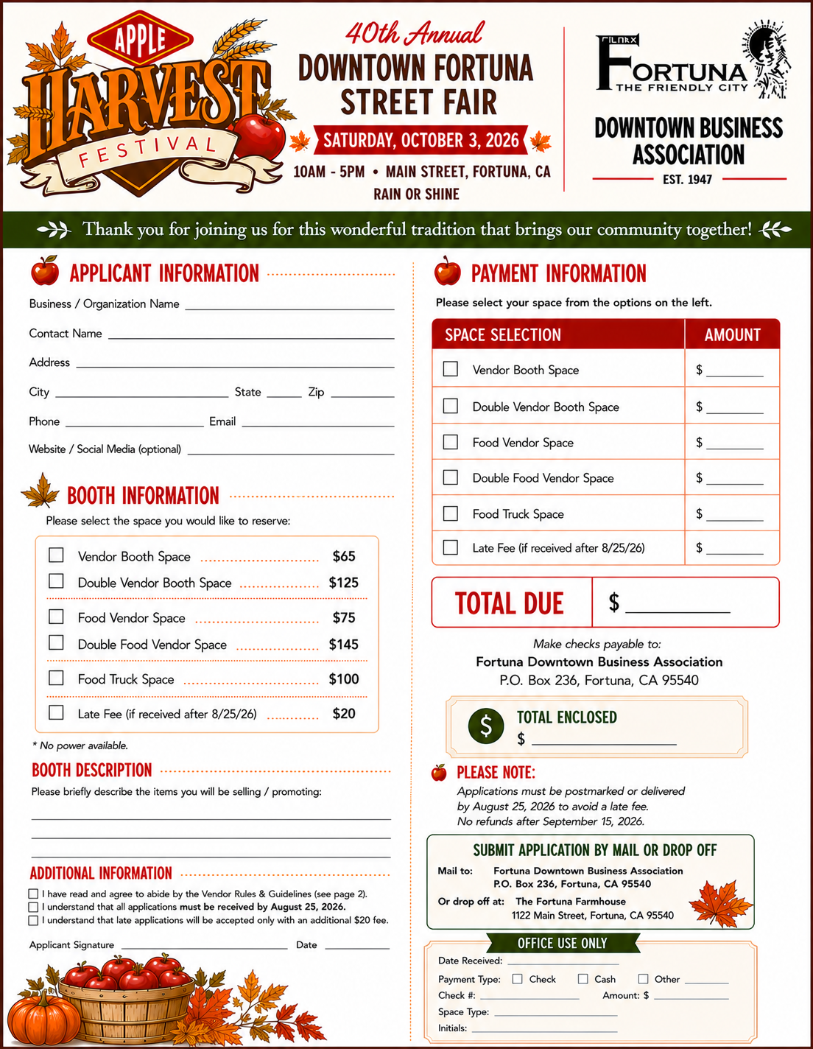
Vendor Guidelines:

● Spaces will be assigned on a “first come, first serve” basis, so REGISTER EARLY!
● Previous years spaces are not guaranteed (new things coming this year!)
● No applications will be accepted after September 30th, 2025
● No early breakdown NO vehicles allowed on Main Street until after 4:10pm
● Vehicles must be off Main St. by 8:30 am. No vehicles on Main St. between 8:30 am & 4:10 pm
● This is a pet-free event (Service animals only)
● Sellers permit required and event insurance is recommended
● All vendors must park in designated areas after unloading at your booth. (No parking in the alleys. Violators will be towed at their own expense. All applicable Fortuna Vehicle & Municipal Code violations will be addressed by the Fortuna Police Department.
● All booths will be located touching the sidewalk; please do not put anything on the sidewalks. If your booth requires electricity, quiet generators are allowed. No electricity is provided.
● All vendors will be notified of space number 1 week before the event.

